Tara Walton

Analysis is difficult as I still have issues in my code. For seem reason, the code does not work for some very small sets (ie, 1, 2).

There is also the matter that blocking models are set in different ways. I used a random number draw and a subset to create a “percent chance” that a process would be blocked. The subsequent priority queue sorts the queue based on the next event time, priority, and the run time remaining.

It appears that the process of blocking is detrimental to the smaller set of data, but as more and more processes vie for limited resources, more processed can be completed by allowing certain processed to be placed on the back burner and allow smaller or higher priority processes to pass through to completion.

I wish I would have had more time to really delve into the details and implement the animation. I’m a visual person and I would have liked to have SEEN the outcomes as I tweeked each policy for each queue.

I’ve attached screenshots of my outcomes for comparisons.

Before blocking:

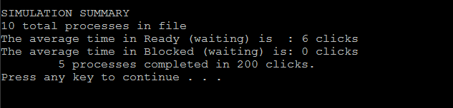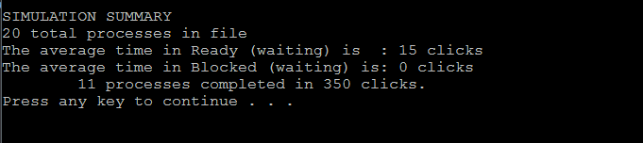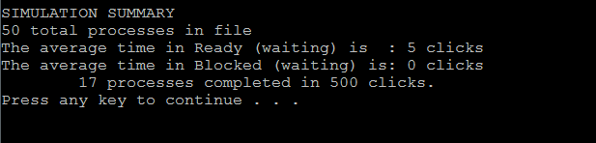

After blocking:  
